Problem Name: Convolution Properties of fourier representation

Source Code:

clc;

clear all;

close all;

syms t w

x = exp(-3\*t) \* heaviside(t);

y = t \* exp(-3\*t) \* heaviside(t);

X = fourier(x,w);

Y = fourier(y,w);

H = Y/X;

h = ifourier(H,t);

t1 = 0:.01:5;

x = exp(-3\*t1);

h1 = subs(h,t,t1);

h = double(h1);

y1 = conv(x,h)\*.01;

subplot(2,1,1);

ezplot(y,[0,10]);ylim([0 .25])

subplot(2,1,2);

plot(0:.01:10, y1);

Output:

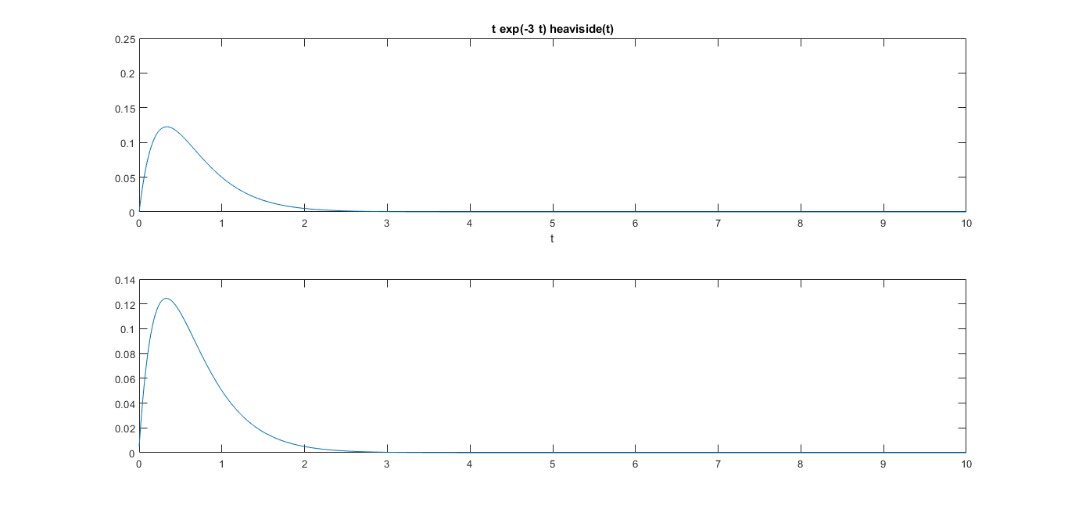

Problem Name: Convolution Properties of laplace representation

Source Code:

clc;

clear all;

close all;

syms t

syms w

x = exp(-3\*t) \* heaviside(t);

y = t \* exp(-3\*t) \* heaviside(t);

X = laplace(x,w);

Y = laplace(y,w);

H = Y/X;

h = ilaplace(H,t);

%convolution

t1 = 0:.01:5;

x = exp(-3\*t1);

h1 = subs(h,t,t1);

h = double(h1);

y1 = conv(x,h)\*.01;

subplot(2,1,1);

ezplot(y,[0,10]);ylim([0 .25])

subplot(2,1,2);

plot(0:.01:10, y1);

Output:

